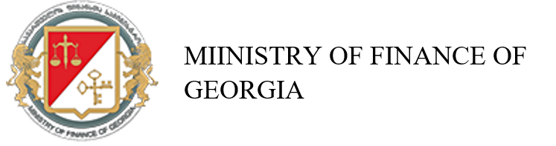
16 Gorgasali Str. 0105 Tbilisi

Application to be recognized as a Primary Dealer in Debt Securities of the Republic of Georgia

Name of Financial Institution:
Address:
Identification Number:

Name of Authorized Representative Person:
Title:
Phone:
E-mail:

Signature

Date of Application

